Project Title

Software Requirements Document

Version: 1.0

Date:11/24/15

Prepared by Christopher Fajardo

Table of Contents

1. Preface 4
1.1. Modification History 4
1.2. Intended Audience 4
2. Introduction 4
3. Glossary 4
4. User Requirement Definition 4
5. System Requirements Specification 5
6. System Architecture 5
7. System Models 5
7.1. Use Case Diagram 5
7.2. Sequence diagram 5
7.3. Class diagram 5
8. System Evolution 5
9. Appendices 5
10. Index 5

Table of Figures

Figure 1 ABC 8
Figure 2 DEF 18
Figure 3 XYZ 20

Preface
This should define the expected readership of the document and describe its version history, including a rationale for the creation of a new version and a summary of the changes.

Modification History

Date | Version | Author | Summary of changes
11/24/2015 | V1.0 | Christopher Fajardo | Started document

Intended Audience
This document is intended for all stakeholders of the effort.

Introduction
Describe the need of the system. It should briefly describe its function and explain how it will work with other systems. It should describe how the system fits into the overall business or strategic objectives of the organization commissioning the software.

Purpose of the requirements document
This document should show all the requirements and instructions of this project

Scope of the product
This system should be able to manage the clientele and staff of the bank

Reference

Overview of the reminder of the document

Glossary
Define technical terms used in the document.

Term | Meaning
Product users | These are users who interact with the system directly. For instance, employees- supervisors, project managers, project engineers and admin.

User Requirement Definition
The services provided for the user and the non-functional system requirement should be described in this section. This description may use natural language, diagrams or other notations that are understandable by customers.
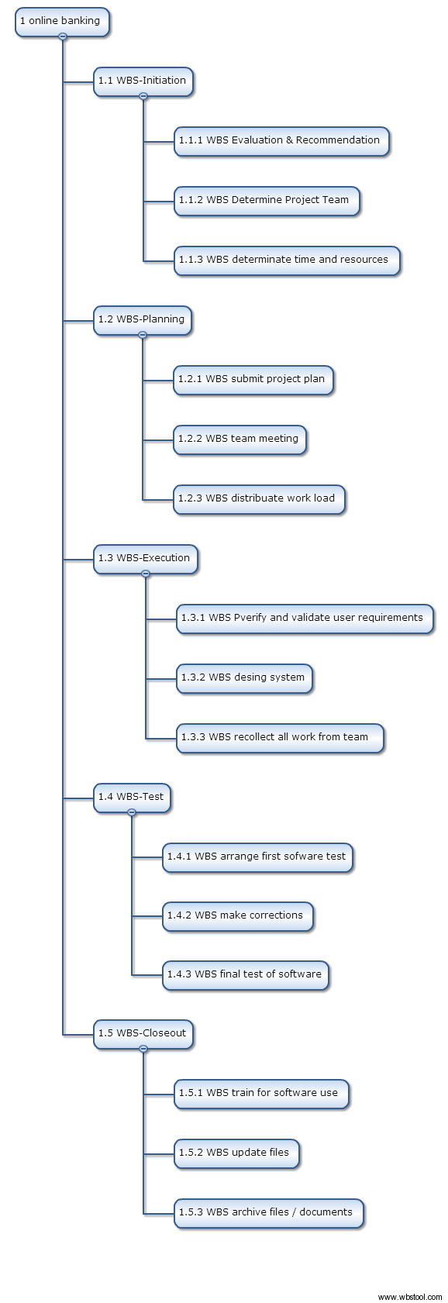

System Requirements Specification
This should describe the functional and nonfunctional requirements in more detail. If necessary, further detail may also be added to the non-functional requirements, e.g. interfaces to other systems may be defined.

Online banking: the requirements of a simplified online banking system
5.1 Each account contains account numbers, saving and checking accounts, information of the users, transfers options, various options for the user (client) such withdraws and deposits. In addition each access will have a log in, log out option
5.2 The system will keep track of saving and checking accounts and provide a statement of the history of transactions for the client , also give options of deposits and withdraws , transfer of money from checking to saving, and printouts .
5.3The system will also give administration access to all accounts for tellers. Make similar actions as users but could also create new accounts.

System Architecture
Present the high-level overview of the anticipated system architecture. Architectural component that are reused should be highlighted.

System Models
This should include one or more system models showing the relationships between the system components and the system and its environment. These might be use case diagram, sequence diagram and class diagram.

Use Case Diagram
- Client
  - Make deposit
  - Make withdraw
  - Make transfer (from saving to checking and vice versa)
  - Print records
- Teller
  - Update clients information
  - Make accounts
  - Make deposit
  - Make withdraw
  - Make transfer (from saving to checking and vice versa)
  - Print records

Sequence diagram
This should include the diagram and a text description of the diagram.

User:customer

Customer:login()

Customer:Makedeposit() (choose where to deposit)

Savingaccount:amount

Class diagram
Customer
Id:int
Name:String
Phone:String
Address:String
Makedeposit()
Makewithdraw()
Maketransfer()
Print()
Login()
Logout()
.

System Evolution
Describe the fundamental assumptions to which the system is based and anticipated changes due to hardware evolution, changing user needs, etc…

This application has a bright future in where the increase of data and the need of management is going to be needed.
More Data space is going to be required and some bugs might be expected with the user interaction .

Appendices
Describe any additional information related to the application.

Index
Several indexes to the document may be included- alphabetic index, index of diagrams, index of functions, etc…

